***Chemistry***

**18:Representative Metals, Metalloids, and Nonmetals**

**18.11: Occurrence, Preparation, and Properties of Halogens**

101. Why is SnCl4 not classified as a salt?

Solution

SnCl4 is not a salt because it is covalently bonded. A salt must have ionic bonds.

103. Which is the stronger acid, HClO3 or HBrO3? Why?

Solution

In oxyacids with similar formulas, the acid strength increases as the electronegativity of the central atom increases. HClO3is stronger than HBrO3; Cl is more electronegative than Br.

105. Predict the molecular geometries and draw Lewis structures for each of the following. You may wish to review the chapter on chemical bonding and molecular geometry.

(a) IF5

(b) 

(c) PCl5

(d) SeF4

(e) ClF3

Solution

(a)

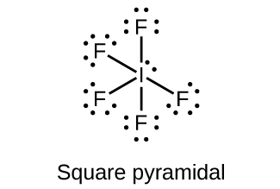;

(b)

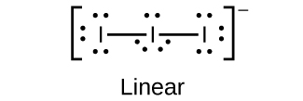;

(c)

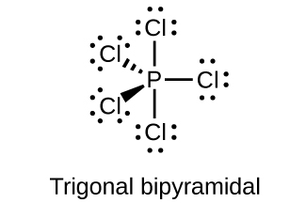;

(d)

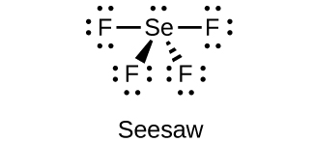;

(e)

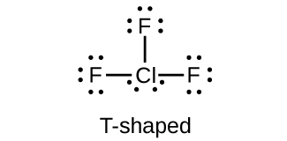

107. Name each of the following compounds:

(a) BrF3

(b) NaBrO3

(c) PBr5

(d) NaClO4

(e) KClO

Solution

(a) bromine trifluoride; (b) sodium bromate; (c) phosphorus pentabromide; (d) sodium perchlorate; (e) potassium hypochlorite

109. What is the oxidation state of the halogen in each of the following?

(a) H5IO6

(b) 

(c) ClO2

(d) ICl3

(e) F2

Solution

(a) I: 7+; (b) I: 7+; (c) Cl: 4+; (d) I: 3+; Cl: 1–; (e) F: 0

This resource file is copyright 2015, Rice University. All Rights Reserved.